**VCO1 726 test measurements, 7 April 2016**

Readings were made using my Chinese transistor tester, bought through eBay. Three measurements were made for each transistor. The transistor type is NPN.

Transistor 1 (pin connections 9, 10, 1)

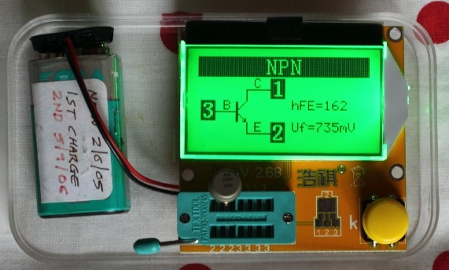

hFE: 162

Uf (mV): 735

Transistor 2 (pin connections 2, 3, 4)

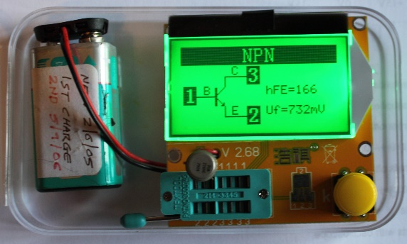

hFE: 166

Uf (mV): 732

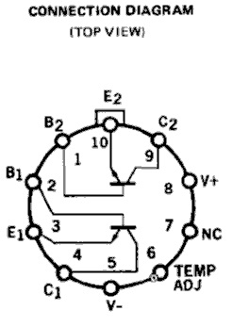

The gain values appear to be well matched. T1 and T2 differing by 2.4%, i.e. (166-162)/164*100. The datasheet spec suggests DOES IT? matching better than 3% should be achieved, which it is.